**ASSIGNMENT 1**

1. SELECT product_id,product_name,unit_price FROM products

WHERE unit_price < 20

ORDER BY unit_price ASC

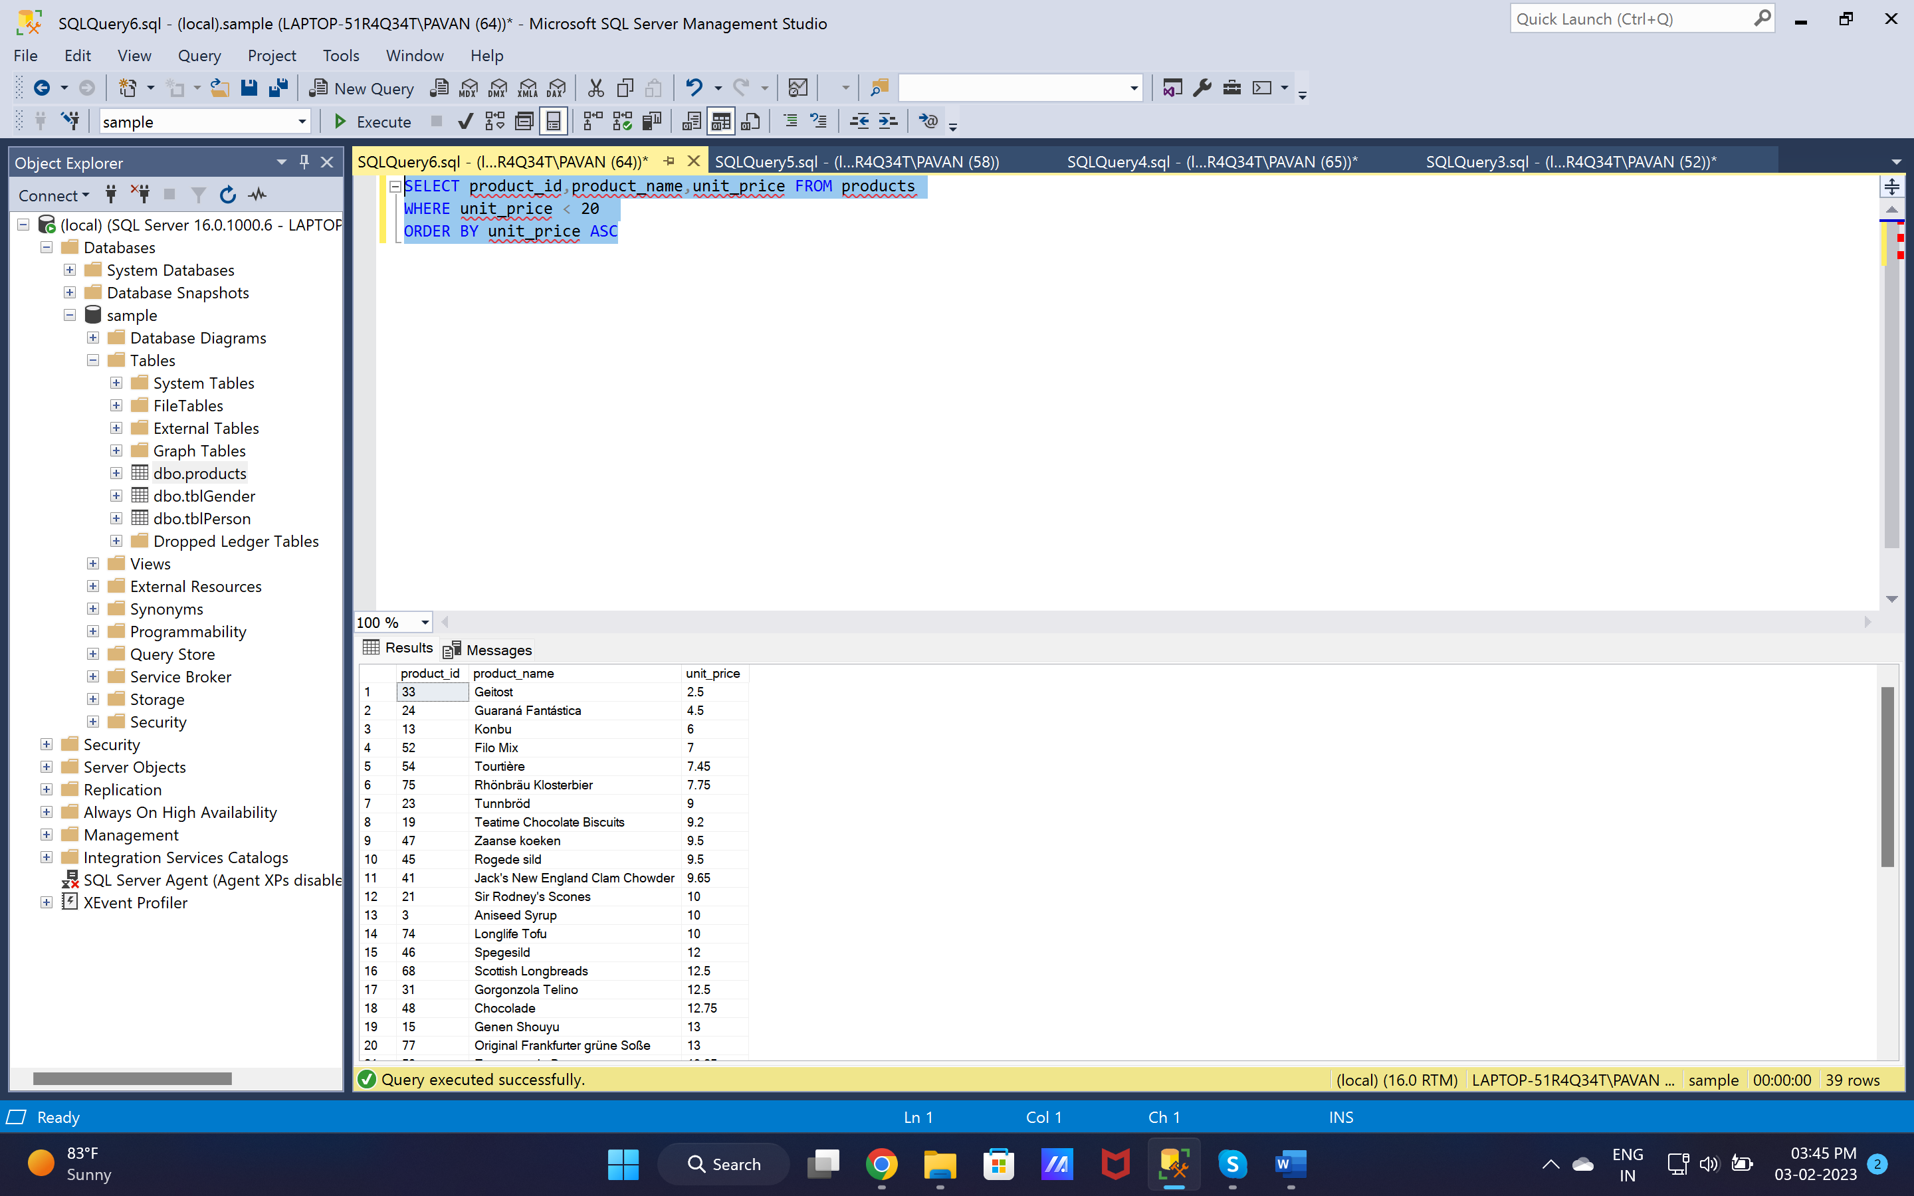

1. SELECT product_id,product_name,unit_price FROM products

WHERE unit_price < 25 AND unit_price > 15

ORDER BY unit_price ASC

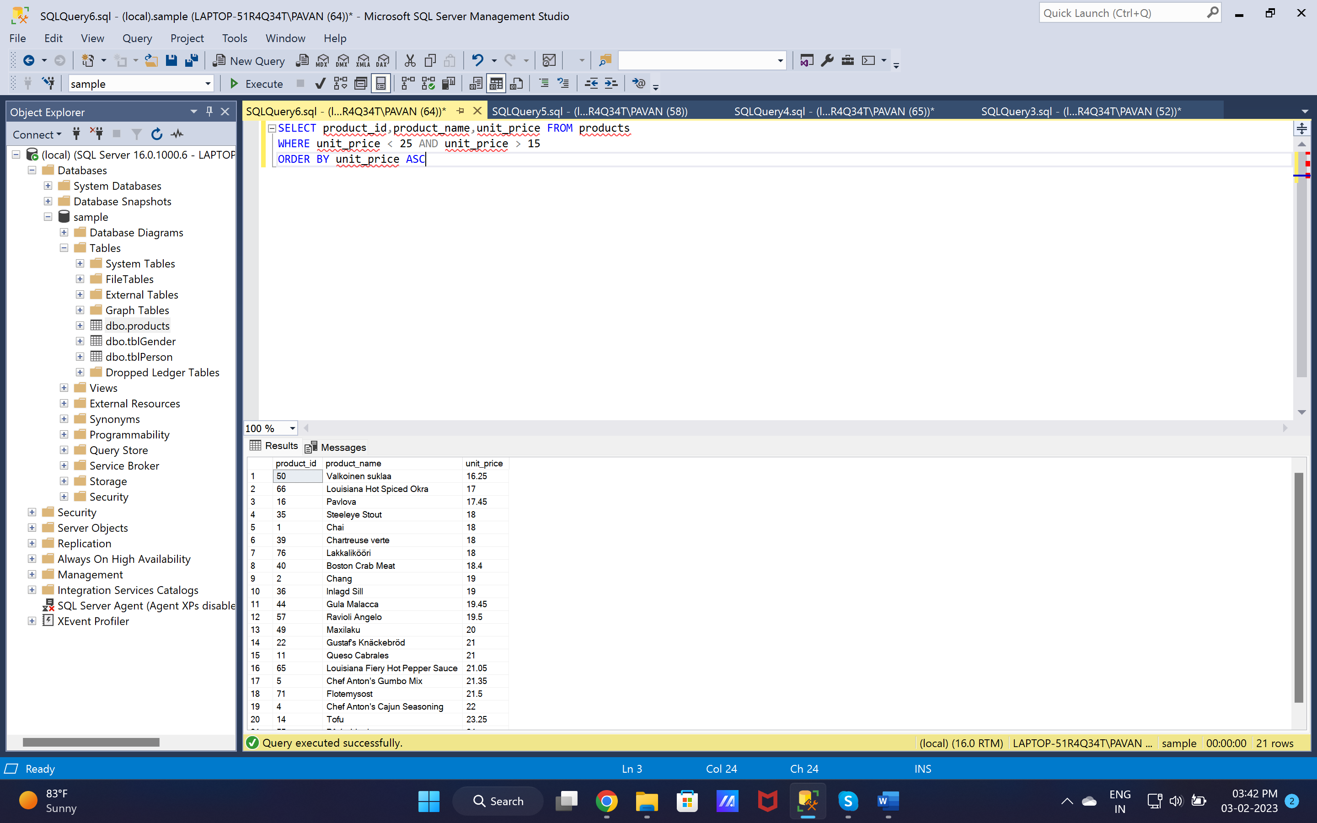

1. SELECT product_name,unit_price FROM products

WHERE unit_price > (SELECT AVG(unit_price) FROM products)

ORDER BY unit_price ASC

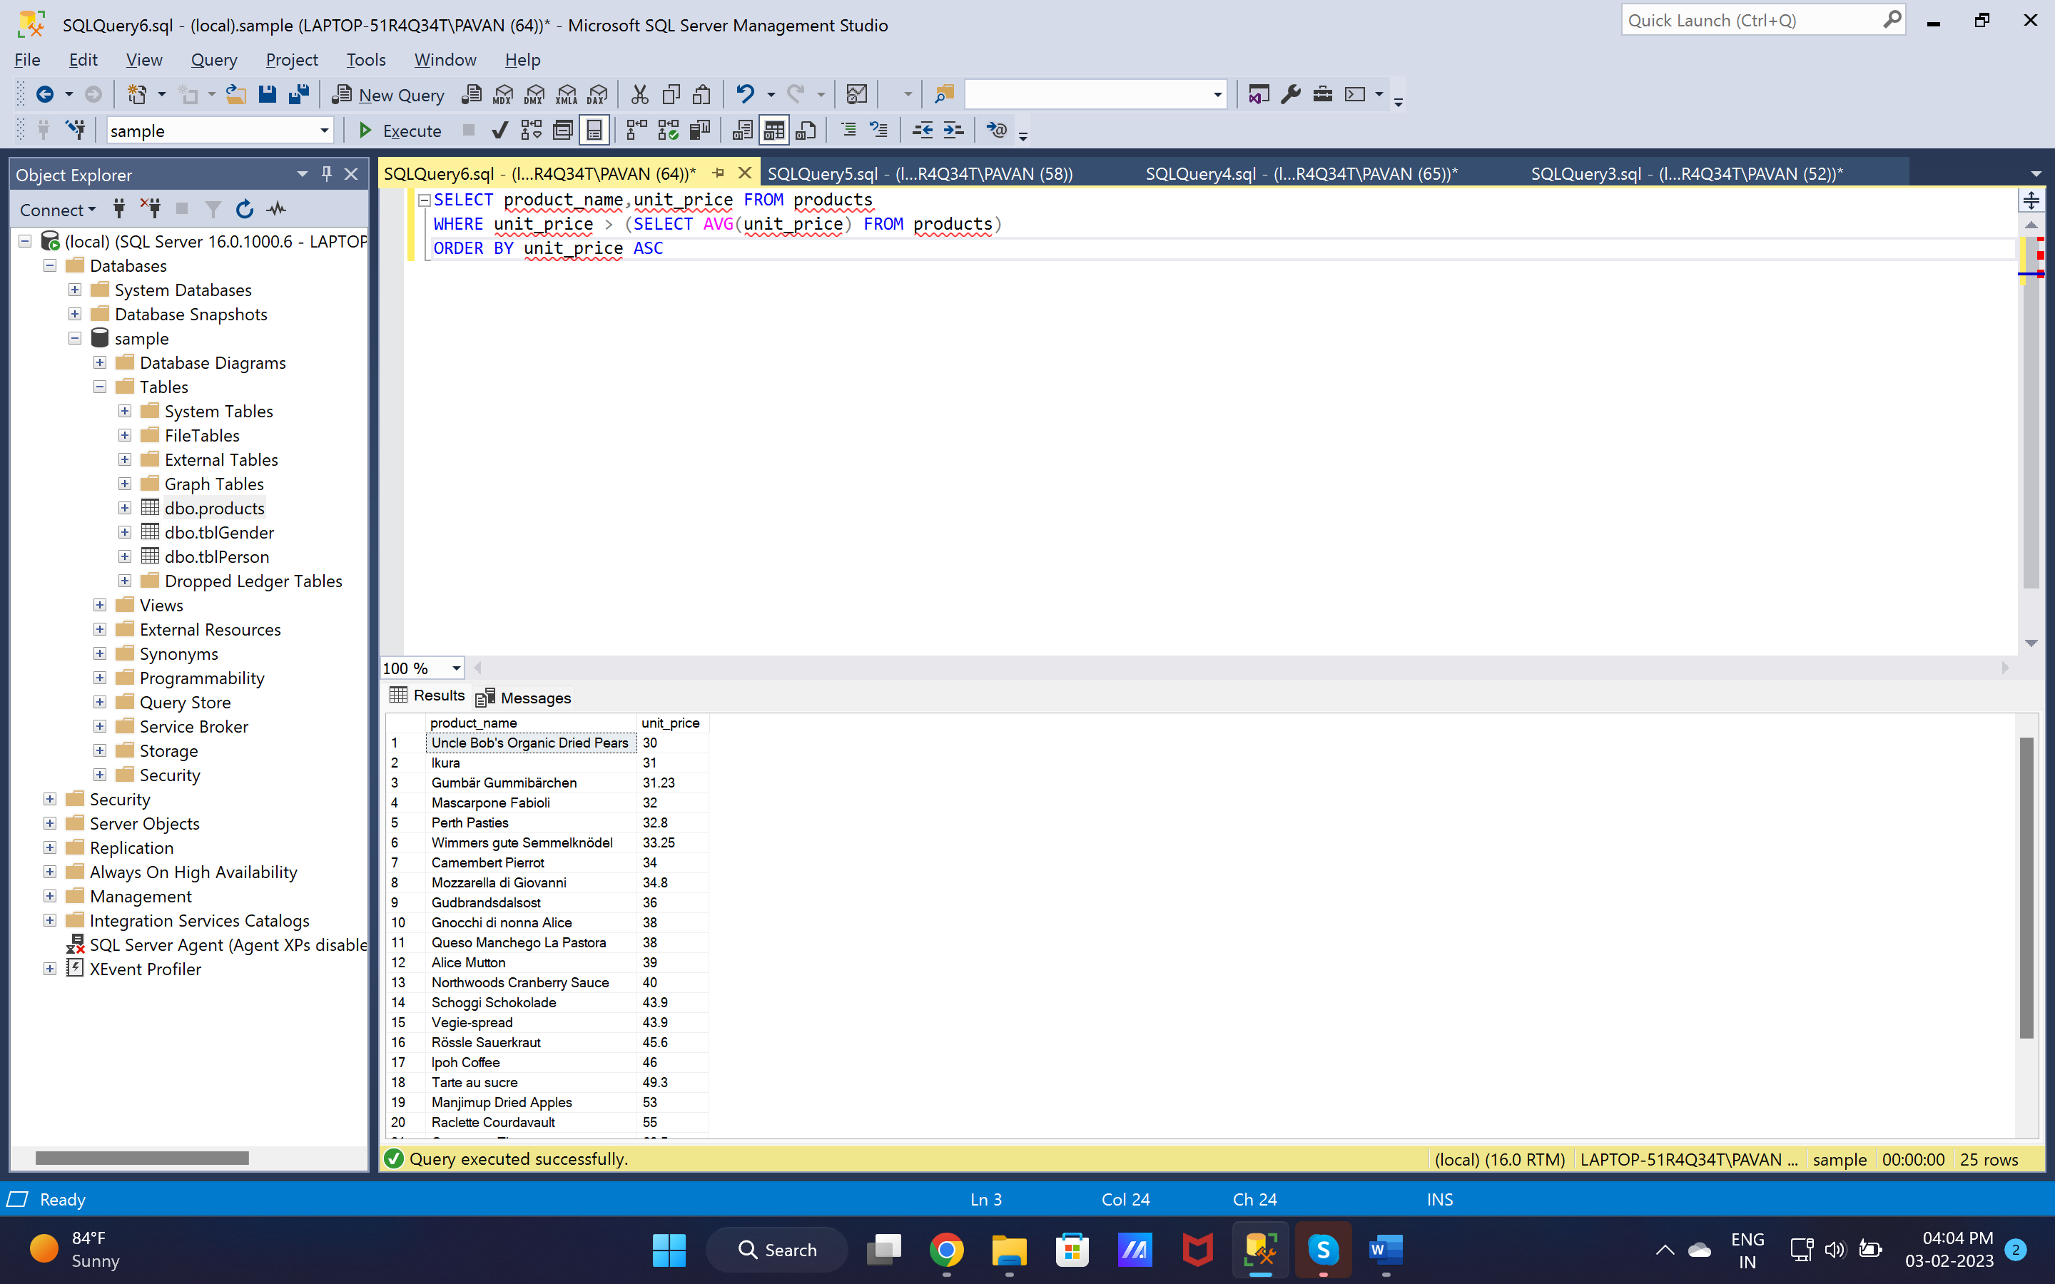

1. SELECT top 10 product_name,unit_price FROM products ORDER BY unit_price DESC

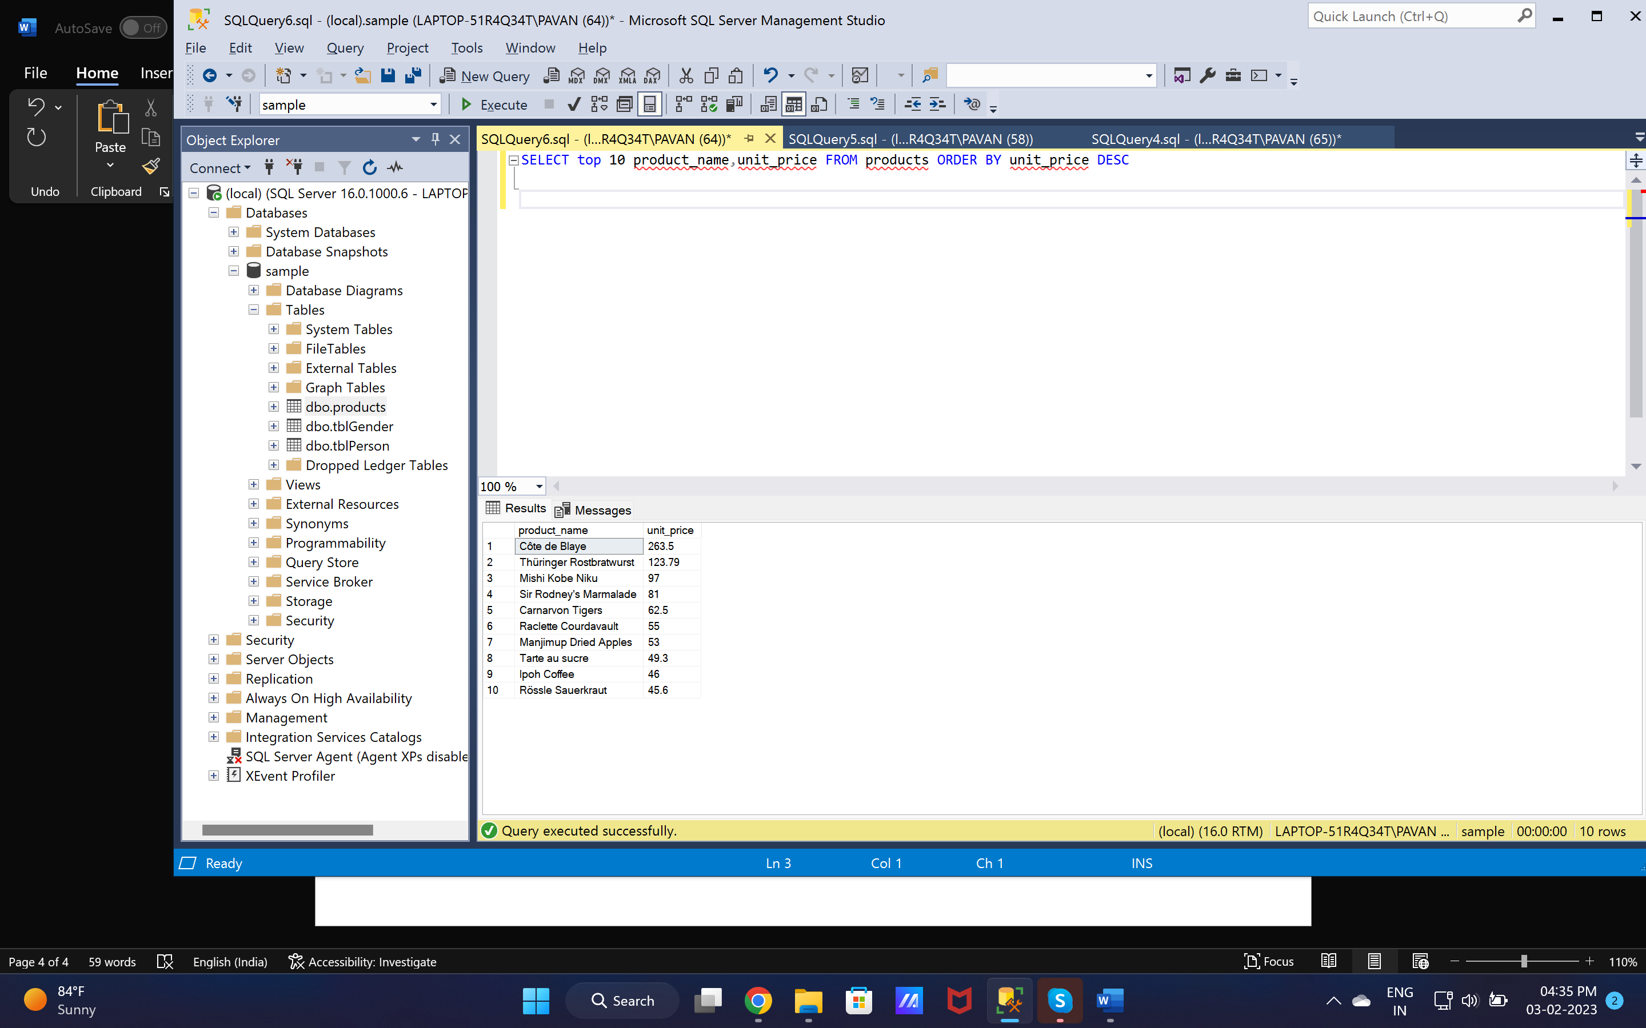

1. SELECT discontinued, COUNT(1) FROM products GROUP BY discontinued

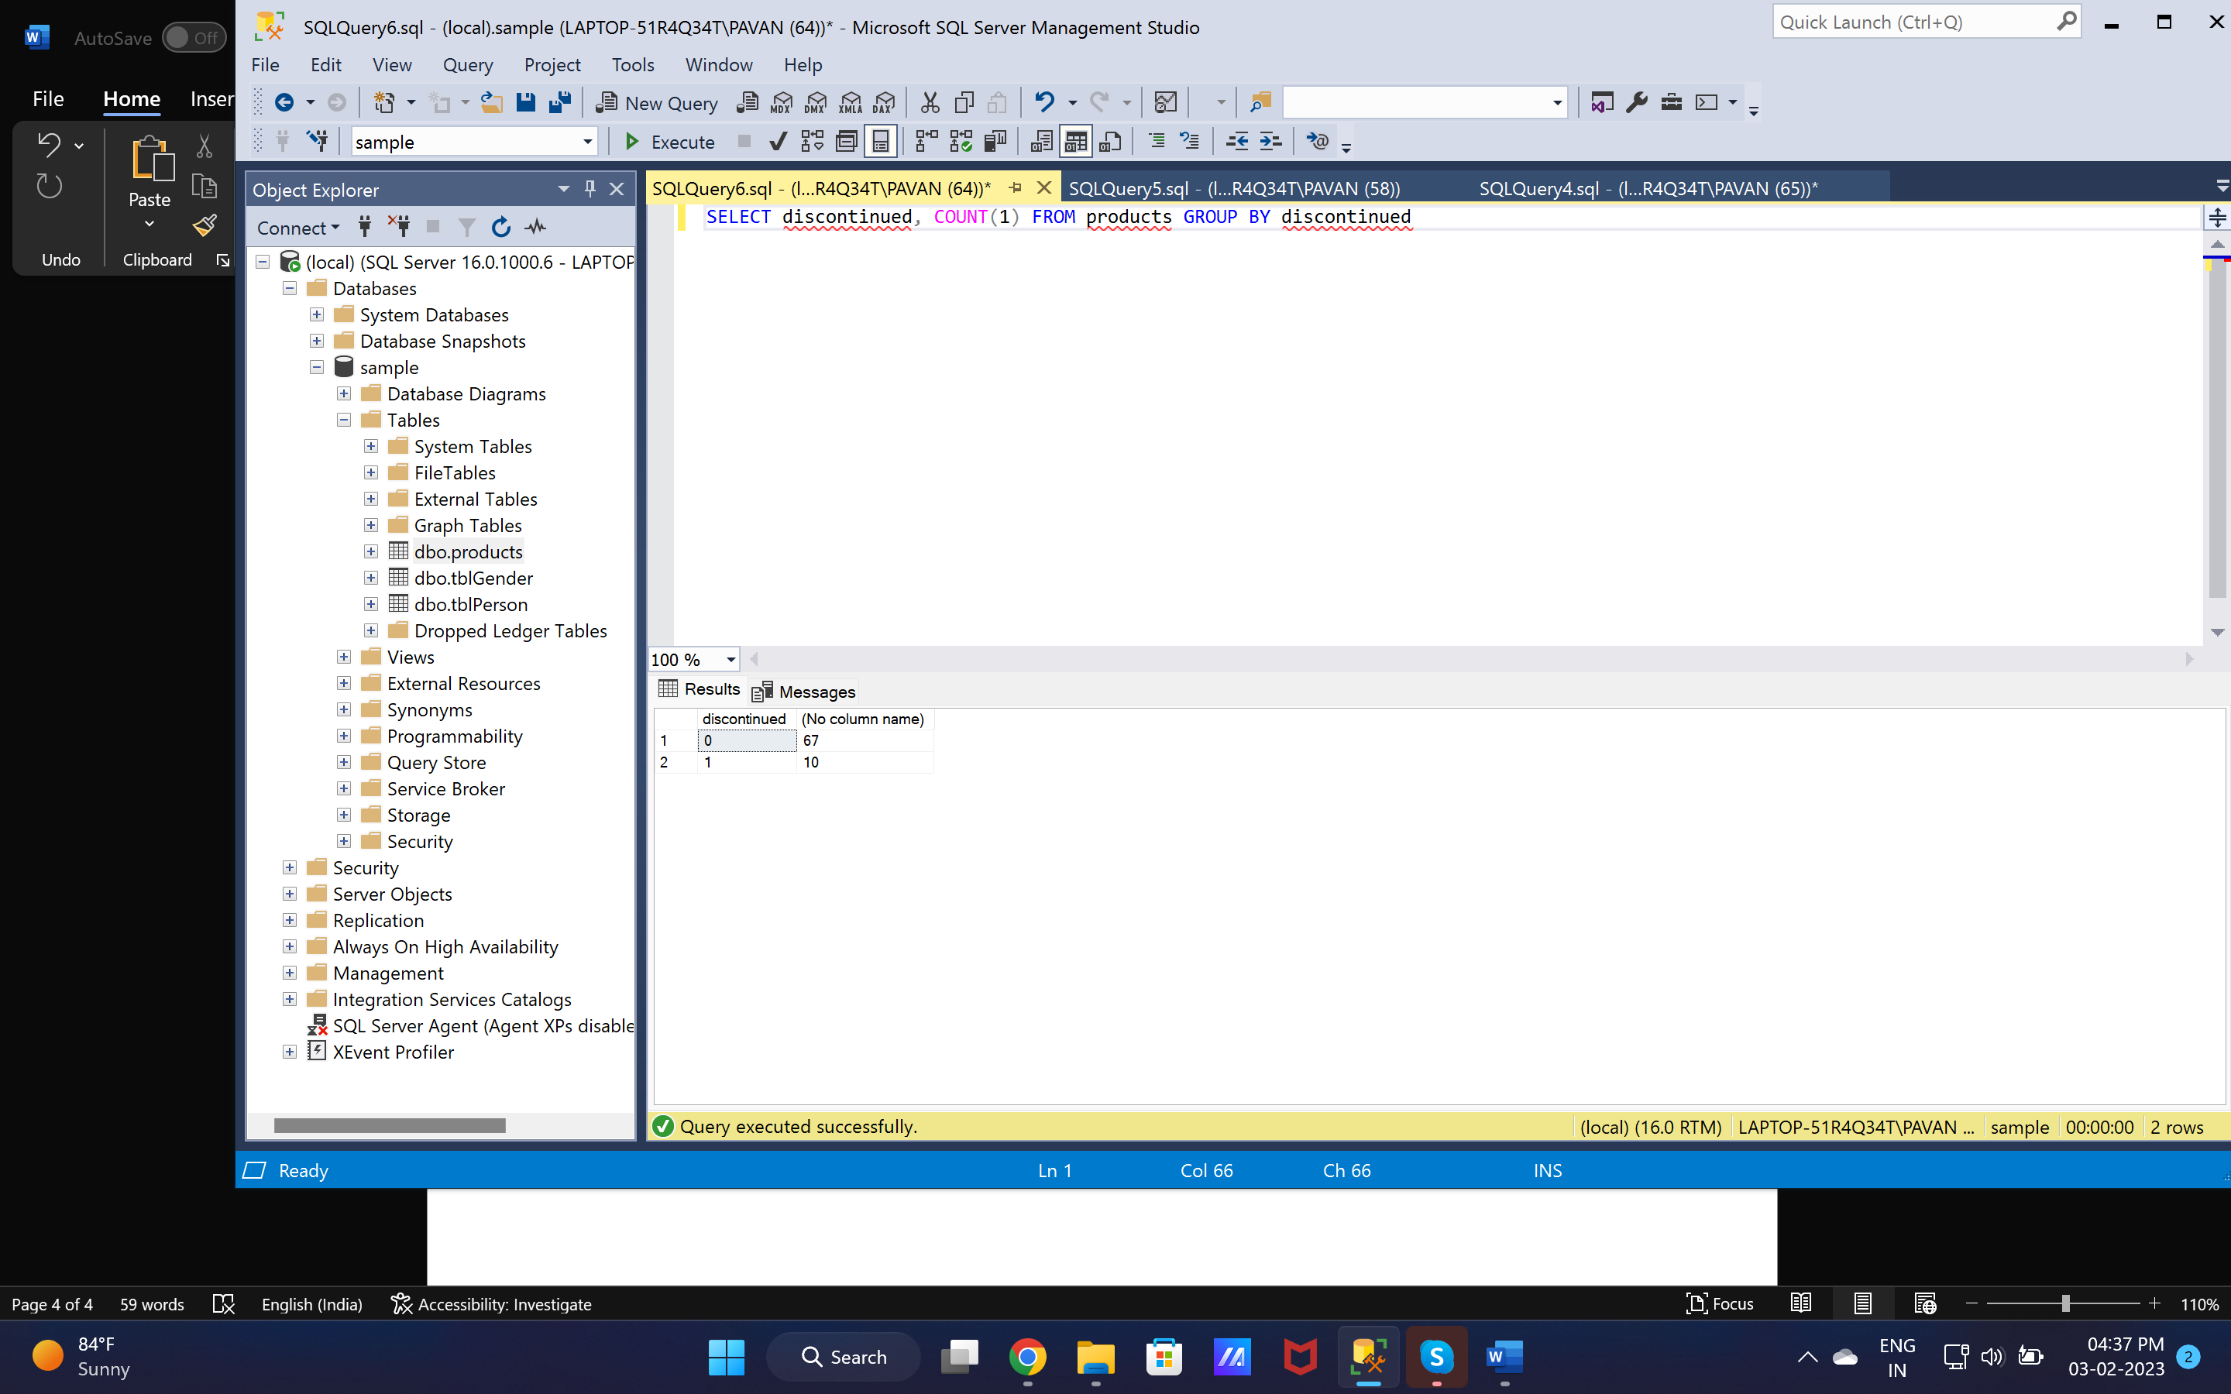

1. SELECT product_name,units_on_order,units_in_stock from products

WHERE units_in_stock < units_on_order

